MindSpace - Self-awareness tool for mental wellbeing

Team 24: Eric Ka Yiu Ma, Yingyao Lu, Yiu Yeung Ng, On Ki Ng

Client: Dr Thushari Atapattu, Menasha Thilakaratne

**Key components**

**Used Software & Tools**

|  |  |
| --- | --- |
| Milestone 1   1. Create all pages with functioning routing and navigation. 2. Full functionalities of ‘Landing’ page as the first screen after opening the application. 3. Frontend design of ‘Sign up & Login’ page. 4. Frontend functionalities of ‘Home’ screen. | Milestone 2   1. Full functionalities of ‘Explore’, ‘Strategies’, ‘Insight’ and ‘Timeline’ page. 2. Backend endpoint for uploading and retrieving insight input by users. 3. Import ‘trigger keyword sample data’ to test the backend functionalities. 4. Modify backend endpoint for trigger keywords and number of occurrences of each emotion detected. |

**Milestones**

1. We have finished all the milestone and clients’ requirement, the full functionalities of project MindSpace are implemented.
2. MindSpace visualizes user emotion data in daily, weekly, and monthly basis.
3. MindSpace stores user data using Django sever running with MySQL database for sending and retrieving data.
4. MindSpace provides user login and signup service by using authentication service in firebase.

**Conclusion**

We have finished all the activities listed on Milestone 1 and 2.

Extra tasks required by clients are also accomplished:

1. Authentication using Firebase which supports user sign-in with email and Google account.
2. Setting up a database in Django server for creating, reading, and updating user’s information, emotion record, and reflection input.

**Achievements**

1. Retrieve data from social media and keyboard.
2. Cross platform availability to be deployed to both iOS and Android.
3. Provide strategies for handling emotion by our own and paid mediation courses for profit.

**Extensions**

* Ionic - Cross-platform development
* Angular - Single-page client application with HTML, Sass and TypeScript
* Firebase - Token-based authentication
* Django - Python web framework
* Django REST - REST API
* MySQL - Relational database management
* Docker - Consistent development environment and distribution

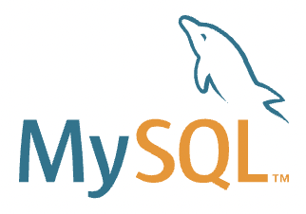

MindSpace User

Ionic mobile app makes API calls to Firebase through HTTP requests to handle user creation and authentication.

Every time a user is successfully authenticated by Firebase, the mobile app will pass the user ID token returned by Firebase to Django server for it to create or retrieve a user record that matches with the one stored in Firebase.

Ionic mobile app makes REST API calls to Django server through HTTP requests to retrieve data of identified emotions and trigger keywords; and save and retrieve reflections submitted by users.

1a

1b

1c



System Admin

Firebase handles user authentication requests from Ionic mobile app and return a user ID token back to ionic mobile app for it to communicates with Django server further.

Firebase informs Django backend server if the user ID token received from Ionic mobile app is a valid one or not.

2a

2b

Interacts with

Loads sample data into

For data security, Django server will pass the user ID token received from Ionic mobile app to Firebase to confirm if the user ID is a valid one or not.

Django server handles REST API calls received from Ionic mobile app and returns requested data of identified emotions, trigger keywords and user reflections.

3a

3b

Save processed data into

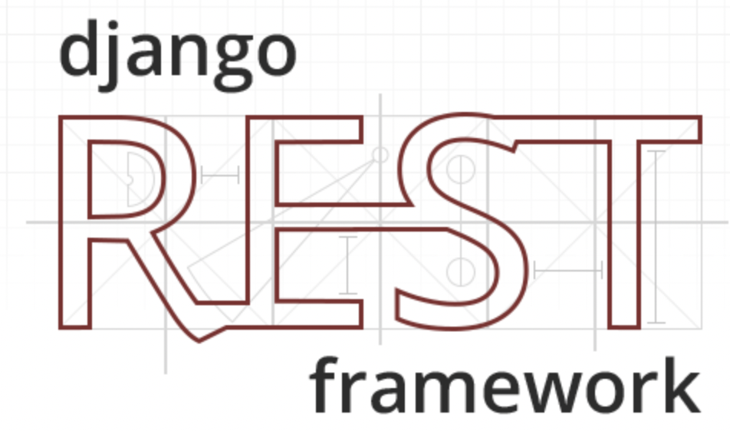

1a

1b, 1c

2a

3a

3b

2b

Token Authorisation: 1a → 2a → 1b → 3a → 2b

After token authorised: 1c → 3b

**Key concepts**

**System Architecture**

**Introduction**

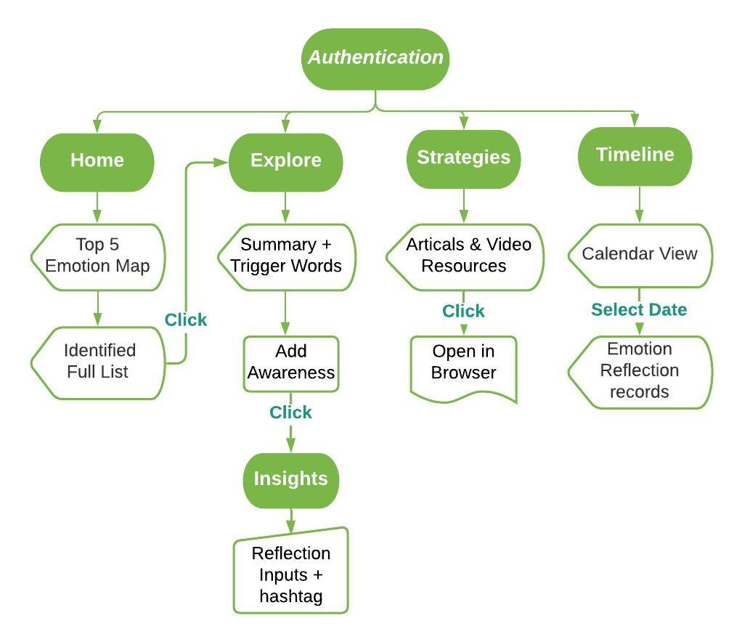

MindSpace is a cross-platform application that aims to help users enhance their emotional awareness.

The application allows users to use a visual dashboard to analyse their emotions identified with their language overtime, make reflections on underlying emotions and triggers, and provides useful resources to cope with emotional problems.